PAECO Annual General Meeting
Bringing together students and professionals for academic and professional advancement

Who: Professional Association of Ethio-Canadians in Ottawa

What: Invitation to the annual general meeting followed by a casual dinner!
- Brief presentations on PAECO`s last year work and finances
- Discuss and vote on proposed changes to the current bylaw
- New executive team elections

When: Saturday, November 19th, 2016
3:00pm – 5:00 pm
Light refreshments will be served
The casual dinner will be at a separate location at 6 PM

Where: Carleton University
1125 Colonel by Drive, Ottawa ON
Richcraft Hall (Previously River Building) Room 3110

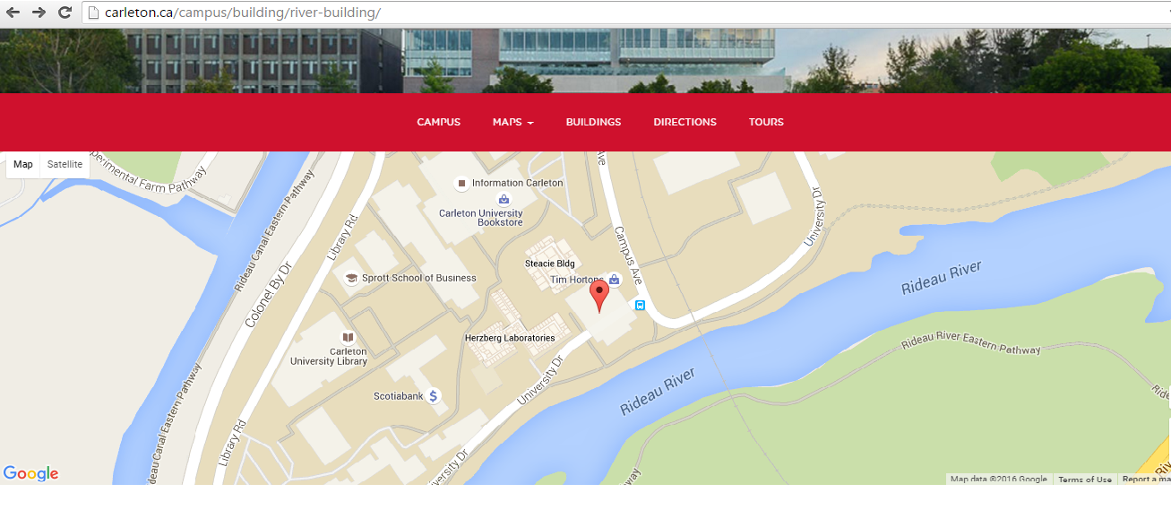

We hope you will join us!

